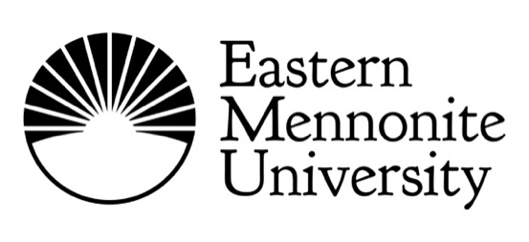

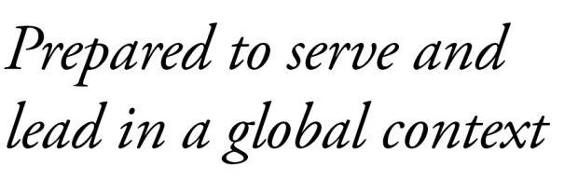

SUMMER 2019 WESTERN DISTRICT MENNONITE CONFERENCE EMU ANNUAL REPORT

Mission Matters
President Susan Schultz Huxman
Greetings from EMU! I am honored to steward this remarkable “Christian University like no other” into its second century. I have found EMU uniquely equipped to give our church and the broader society a special “360” kind of vision:
Hindsight.
Every Mennonite church and school has its sustaining story of the past. Much of ours is captured in the bold centennial history book, authored by Don Kraybill, EMU: A Century of Countercultural Education (Penn State University Press, 2017). Our students, most of whom are not Mennonite, are attracted to and empowered by our counter-culture attention to peacebuilding and what it means to follow Jesus.
Foresight.
Foresight is the ability to see what is coming and embrace our future full-throttle! At EMU, we push the frontiers of what it means to study peace in our culturally diverse world. We are looking ahead not just to prepare our students for a meaningful career, but to “serve and lead in a global context.”
Insight
Insight is the power of apprehending the inner nature of things. Insight is built upon a distinctive witness of “shalom,” steeped in the Good News of the Resurrected Jesus, and practiced in community. At EMU, this inner way of seeing nudges us to take every opportunity to “do justice, love mercy, and walk humbly with God.”
Looking backward. Looking forward. Looking inward and beyond. This is one way to see: Why EMU for Century Two?

EMU Highlights and Happenings
- Judy H. Mullet, a beloved professor of psychology retired this spring after 32 years at EMU, and provided the 101st commencement address on Sunday, May 5. She has taught in the psychology department and MA in education program, as well as directed and advised within the Honors program.
- Wu Wei, a 2006 graduate of Eastern Mennonite Seminary, was named president of the China Christian Council in November 2018, leading an umbrella organization based in Shanghai that oversees more than 60,000 churches and nearly 25 million believers.
- EMU’s celebration of Martin Luther King Jr. Day was styled as a “day on” instead of a “day off.” In place of classes, the community was invited to worship services, a formal convocation program, a ribbon-cutting ceremony for the new student barbershop and salon,
and other events.

How can EMU serve you?
Contact the church relations office to schedule the president or a faculty guest speaker: 540-432-4597 or ChurchRelations@emu.edu.

Our Vision
EMU envisions a learning community marked by academic excellence, creative expression, professional competence,
and passionate Christian faith,
offering healing and hope in our diverse world. To this end, we commit ourselves
to do justice, love mercy and walk humbly with God.

Western District Mennonite Conference Connections to EMU

Undergraduate Students
Seven undergraduate students from Western District Mennonite Conference were enrolled in the spring 2019 semester.

Giving
Western District Mennonite Conference churches gave $7,000 in matching church grants during the year ending June 2018.
 Susan Schultz Huxman, president
 Kirk Shisler, vice president for advancement
 Jasmine Hardesty, director of development & planned giving
 Braydon Hoover, director of development & annual giving
 Lindsay Martin, associate director of development
 Matthew Ruth, director of admissions

