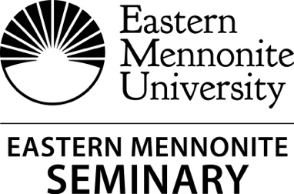
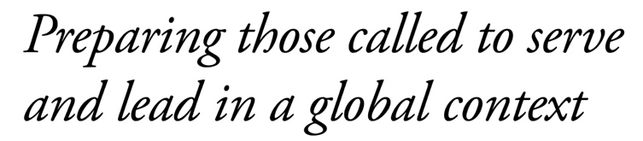

Summer 2019 WESTERN DISTRICT CONFERENCE SEMINARY ANNUAL REPORT

Seminary and undergraduate Bible, Religion, Theology Department build new relationship
The long-standing interest in working in a more integrated fashion with the undergrad Bible, Religion, Theology department has become a reality. Most faculty now teach in both programs and meet together monthly. Dr. Andrea Saner has been teaching Old Testament for both seminary and undergrad students for several years, and now Dr. Peter Dula and Dr. Andrew Suderman will strengthen our theology and missiology offerings.
New Testament Scholar and Augsburger Lecture Series guest
Renowned New Testament scholar NT Wright spoke to standing room only crowds during his visit November 13-14, 2018 as part of a series on the theme “Discerning the Dawn.” Wright, the keynote for the annual Augsburger lecture, spoke in seminary and undergraduate chapels. Wright's presentations included “The Spirit and the Church’s Task” (based on John 16:4b-15) and “The Day the Revolution Began: Atonement the Right Way Round.” He also met with seminary and Bible major students for conversation and engagement.
2019 School for Leadership Training: January 14-16
January 14-16 marked the 50th annual SLT. The keynote speakers were Sue Park-Hur (MC-USA denominational minister for leadership development), John Pavlovitz (pastor, writer, and activist from Wake Forest, North Carolina), and EMS faculty member Dr. David Evans. The theme was “Thriving in the Stormy Seas of Change” and provided participants with a worshipful and renewing encounter through the narrative of Jesus’ crossing the stormy sea with his disciples in Mark 4:35-41. Visit https://emu.edu/seminary/slt/for more information.
For the most up-to-date information on EMS, give us a call, visit us on the web, “Like” us on Facebook!
emu.edu/seminary
540-432-4257

Statement of Purpose
Eastern Mennonite Seminary prepares men and women to serve and lead in a global context. In response to God’s saving grace, we educate students to bear witness to the gospel of Jesus Christ in the power of God’s Spirit as wise interpreters, mature practitioners, discerning communicators, and transformational leaders.
 Susan Schultz Huxman, president
 Sue Cockley, seminary dean
 Nancy Heisey, associate dean
 Veva Mumaw, seminary admissions, placement & church relations

Intensive Hybrid Course Options
EMS will offer several intensive hybrid courses this fall.
Dietrich Bonhoeffer: Life, Theology & Witness, 3 SH, Mark Thiessen Nation
Introduction to Spiritual Guidance, 2 SH, Kevin Clark
Visit https://emu.edu/seminary/courses/fall for more information on fall courses.
21 Graduated from EMS This Spring
EMS awarded Master of Divinity and Master of Christian Leadership degrees May 5 to the graduating class of 2019. Graduates from Eastern Mennonite Seminary joined those of Eastern Mennonite University for the ceremony at 1:00 p.m. on the campus front lawn. Dr. Judy Mullet was the commencement speaker. Seminary Class president, Tyler Goss (MDiv/MACT) was one of the student speakers at the commencement exercises. Seminary Baccalaureate was held in Martin Chapel on Saturday, May 4 with the theme “Where You Go: Casting an Imaginative Journey” and scripture focus of Luke 5:1-11 and Ruth 1:16-17. Dr. Lonnie Yoder spoke at the baccalaureate/ commissioning service.

